Kwaliteitscontrole Rituals flesjes

In dit document wordt een proces voorgesteld om de kwaliteit van het plakken van de productlabels op de Rituals flesjes beter te borgen.

De volgende uitgangspunten worden gehanteerd:

1. Omdat het een handmatig proces is, is het nagenoeg onmogelijk om een “zero defects” beleid tot te passen, zonder de prijs van het proces significant te verhogen.
2. Alhoewel er in het proces een controle plaatsvind, blijken er nog steeds defecte producten te worden geproduceerd (zie bijlage 1 voor de procesflow)
3. Om een extra kwaliteits controle in te bouwen zal er een additionele steekproef worden gedaan op basis van inspectie level II met een AQL van 1,5%.
4. Aangezien de inhoud van een doos of 96 of 80 stuks is, zal conform de AQL tabellen zoals in bijlage II per doos een steekproef van 5 stuks worden genomen.

Indien er een fout gevonden wordt:

* 1. De afgelopen 3 dozen 100% controleren
  2. De komende 3 dozen 100% controleren
  3. De huidige doos 100% controleren
  4. Indien in al deze bovenstaande controles geen extra fouten worden geconstateerd zakt de steekproef terug naar 5 flesjes per doos.

1. Op de dozen die gecontroleerd zijn zal een sticker worden geplakt met:

* Artikel nummer
* Productnaam en type plaatje
* Uniek referentienummer

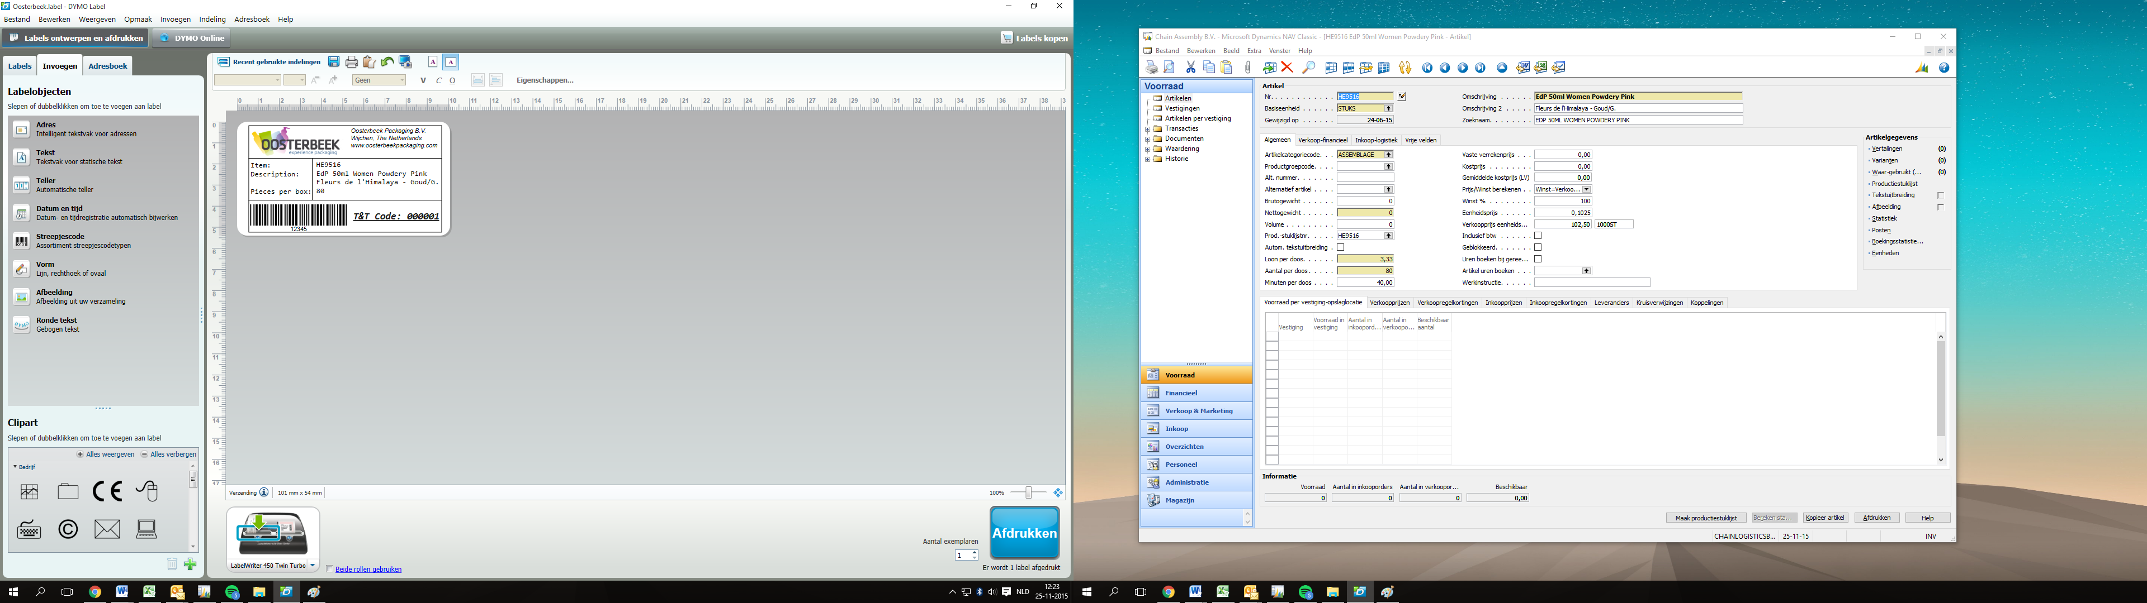

1. De geïnspecteerde dozen worden tevens geregistreerd op een traceerlijst, zodat de kwaliteit aantoonbaar is.Bijlage 1: Processflow



**Bijlage 2: AQL uitgelegd**

**What is the “AQL”, and when it is applicable?**

[4](https://qualityinspection.org/what-is-the-aql/)

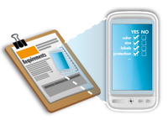The “AQL tables” are statistical tools at the disposal of buyers (for product inspections). They are an industry standard. Most suppliers involved in international trade are familiar with it.

They help determine two key elements:

* How many samples should be picked and inspected, among a batch of product or parts?
* Where is the limit between acceptability and refusal, when it comes to defective products?

**The need for an objective measurement of quality**

In certain product categories, there will be defective products in virtually every production batch. It is often true even after the manufacturer has checked each individual product and has repaired the defective ones, since visual inspection is not 100% reliable.

Therefore, in many supplier/buyer relationships (particularly when the application does not result in life or death outcomes), the supplier is not expected to deliver defect-free goods. The buyer needs to control the quality of purchased goods, since he does not want *too many* defects. But what does “too many” mean?

How to set the limit between acceptability and refusal in a way that can be agreed upon and measured?

**Definition and application of ‘AQL’**

The limit, as described above, is called the ‘AQL’. It stands for ‘Acceptance Quality Limit’, and is defined as the “quality level that is the worst tolerable” (source: [ISO 2859-1 standard](http://www.iso.org/iso/iso_catalogue/catalogue_tc/catalogue_detail.htm?csnumber=1141)).

For example: “I want no more than 1.5% defective items in the whole order quantity, on average over several production runs with that supplier” means the AQL is 1.5%.

In practice, three types of defects are distinguished. For most consumer goods, the limits are:

* 0% for critical defects (totally unacceptable: a user might get harmed, or regulations are not respected).
* 2.5% for major defects (these products would usually not be considered acceptable by the end user).
* 4.0% for minor defects (there is some departure from specifications, but most users would not mind it).

These proportions [vary](https://qualityinspection.org/how-to-choose-an-aql-limit/) in function of the product and its market. Components used in building an airplane are subject to much lower AQL limits.

Note that this tool is used mostly during final outgoing inspections (when the products are ready to be shipped out), and sometimes during production (when the number of products is sufficient to have an idea of the batch’s average quality).

**Getting familiar with the AQL tables**

Before using the AQL tables, you should know three parameters:

* The ‘lot size’. If you ordered different products, the quantity of each product is a lot size, and it is advised to perform separate inspections for each lot. If you ordered only one product, the lot size is the total batch quantity.
* The [inspection level](http://www.qualityinspection.org/inspection-level/). Different inspection levels will command different numbers of samples to inspect. In this article, we will stick to the so-called “level II” under “normal severity” and to single sampling plans.
* The AQL level appropriate for your market. If your customers accept [very few defects](http://www.qualityinspection.org/china-factory-quality-standard/), you might want to set a lower AQL for both major and minor defects.

There are basically two tables. The first one tells you which ‘code letter’ to use. Then, the code letter will give you the sample size and the maximum numbers of defects that can be accepted.

**First table: sample size code letters**

[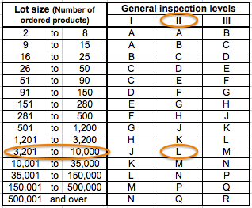](https://qualityinspection.org/wp-content/uploads/2011/11/AQL-example-1.png)

***How to read this table?***

*If you follow my example, I assume your ‘lot size’ is comprised between 3,201 pcs and 10,000 pcs, and that your inspection level is ‘II’. Consequently, the code letter is “L”.*

**Second table: single sampling plans for level II inspection (normal severity)**

[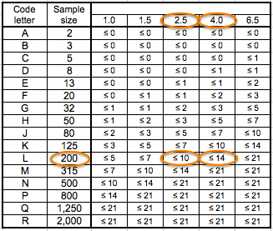](https://qualityinspection.org/wp-content/uploads/2011/11/AQL-example-2.png)

***How to read this table?***

*Your code letter is “L”, so you will have to draw 200 pcs randomly from the total lot size.*

*Besides, I assume you have set your AQL at 2.5% for major defects and 4.0% for minor defects. Therefore, here are the limits: the products are accepted if NO MORE than 10 products with major defects AND NO MORE than 14 products with minor defects are found.*

*For example, if you find 15 products with major defects and 12 products with minor defects, the products are refused. If you find 3 with major defects and 7 with minor defects, they are accepted.*

Note: in [quality inspections](http://www.qualityinspection.org/quality-inspection-services/), the number of defective products is only one of the criteria. It is sometimes called “quality”, or “quality findings”. The other criteria are usually on the inspector’s checklist, which typically includes:

* Packaging conformity (barcodes, inner packing, cartons, shipping marks…).
* Product conformity (aspect, workmanship…). If all the products are in red color instead of orange, there is no need to count each sample as a defect. It makes more sense to refuse for product conformity.
* Specific tests defined in the inspection checklist (they might not be performed on all inspected samples if they are time-consuming or destructive).

**Frequently Asked Questions about AQL**

**Q: So, basically I have to authorize the factory to produce some defects?**

A: In theory no. That’s why the AQL was renamed, from “acceptable quality level” to “acceptance quality limit”.  It is a “limit” (and a loose one at that).

Here is what the ISO2859 standard says:

“Although individual lots with quality as bad as the acceptance quality limit may be accepted with fairly high probability, the designation of an acceptance quality limit does not suggest that this is a desirable quality level. Sampling schemes […] are designed to encourage suppliers to have process averages consistently better than the AQL.”

Note that, in practice, using these statistics means you assume the factory cannot reasonably be expected to turn out 100% good quality.

Alternatively, you can choose an “acceptance on zero” plan. As soon as one defect is found, the inspection is failed. But you can impose this to suppliers only in situations where quality requirements are very high (in the auto industry, in aerospace…).

**Q: Based on my AQL, I calculated the proportion of defects authorized. Why don’t they correspond to the maximum number of defects authorized?**

A: It is true. In our example above, 2.5% of 200 samples is 5 samples, but we accept the goods even if 10 samples are found with a major defect.

Why this difference? There are heavy statistics behind this issue. To keep it simple, the producer’s risk is his risk of rejection (based on the random element when drawing the sample) even though his products (if they were all checked) would be accepted. That risk is about 5% in this standard. And, along the same logic, there is a consumer’s risk and is is around 10%. As you can see, this standard is favorable to the producer’s side.

**Q: Why not just say, ‘we’ll check 10% of the quantity’, or whatever percentage deemed appropriate?**

A: Here again, the statisticians tell us it is not that simple. As we go up in the total quantity, the proportion of products checked can decrease, *for the same confidence in the inspection results*.

As you can see in the chart below, the number of samples to check (vertical axis) increases at a slower pace than the total quantity (horizontal axis).

[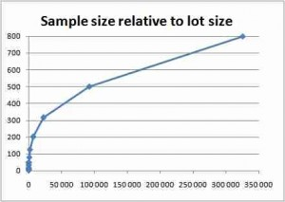](https://qualityinspection.org/wp-content/uploads/2011/11/sample-size-relative-to-lot-size.jpg)

**Q: How to choose an AQL limit for my products?**

A: [See this article](http://www.qualityinspection.org/how-to-choose-an-aql-limit/). It depends on your distribution channel and your product’s end use. Note that your supplier might refuse AQL limits they estimate as too tight (i.e. too low).

**Q: What are the “reduced” and “tightened” severities?**

A: They are designed to be used in very specific situations, when a producer is particularly reliable, or on the contrary fails too often.

In practice, these severities are seldom used. Most inspections are done in normal severity. That’s unfortunate, because the rules to switch from normal to reduced or tightened are considered a very important part of the standard (actually the evolutions of these rules constituted the main changes from MIL-STD 105A and MIL-STD 105E).

**Q: What are the limits of a quality control approach based on random sampling and AQL limits?**

A: There are several limits:

1. An AQL limit is a target rather than a maximum. The buyer might have a nasty surprise when receiving a batch of products that “passed” the inspection. [Read more in this article](http://www.qualityinspection.org/limits-quality-inspections/).

2. A statistical QC approach does nothing to reduce the defects in the first place. [Read more in this article](http://www.qualityinspection.org/quality-expensive/).

**Q: Where can I learn more about the AQL?**

If you really want to understand the concept of the AQL, you should spend about 20 minutes (total) watching these 3 videos on Youtube.

* [How to Read the AQL Tables](http://www.youtube.com/watch?v=hFscyKpA4n0)
* [When Applying the AQL tables Does or Doesn’t Make Sense](http://www.youtube.com/watch?v=p6hyBDi1Y7M)
* [Why the AQL tables are not in favor of the buyer](http://www.youtube.com/watch?v=8bUe8nQpI0s)